## What is Agile Methodology?

1. An agile methodology is an iterative approach to software development. Each iteration of agile methodology takes a short time interval of 1 to 4 weeks.
2. The agile software development process frequently takes the feedback of workable product. The workable product is delivered within 1 to 4 weeks of iteration.

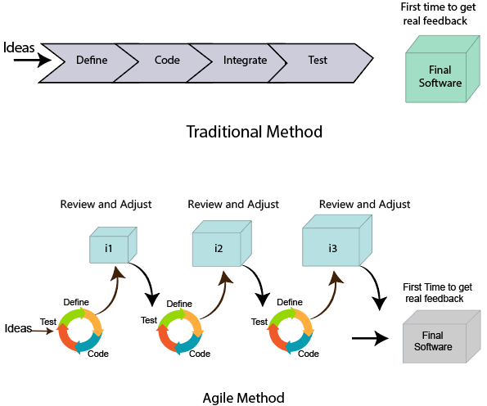

## Roles in Agile

There are two different roles in a Agile methodology. These are the Scrum Master and Product Owner.

Scrum master:

1. The [Scrum Master](https://www.simplilearn.com/everything-you-need-to-know-about-becoming-agile-scrum-master-article) is responsible for creating and onboarding project teams,

2)so so that the team member meets their commitments and customers requirements.

* They enable the close co-operation between all the roles and functions.
* They remove all the blocks which occur.
* Planned meetings
* Daily stand-ups
* Demo
* Review
* Retrospective meetings, and
* Facilitate team meetings and decision-making process.

1. retrospective is **a recurring meeting dedicated to discussing what went well and what can be improved in a sprint**.

### 2. Product Owner

The Product Owner is one who runs the product from a business perspective. The Product Owner plays the following responsibilities:

* He defines the requirements and prioritizes their values.
* He sets the release date and contents.
* He takes an active role in iteration and releasing planning meetings.

## Cross-functional team

Every agile team contains self-sufficient team with 5 to 9 team members. The average experience of each member ranges from 6 to 10 years. The agile team contains 3 to 4 developers, 1 tester, 1 technical lead, 1 scrum master and 1 product owner.

The Scrum master and Product owner are considered as a part of Team Interface, on the other hand remaining members are the part of Technical Interface.

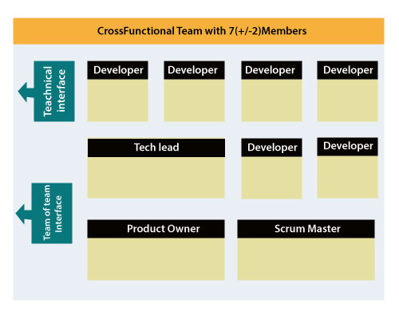

### ****1. An agile project plan is divided into releases and sprints****

 Each release is broken down into several iterations called sprints. Each sprint has a fixed length, typically two weeks, and the team has a predefined list of items to work through in each sprint. The work items are called [user stories](https://monday.com/blog/project-management/user-story-template/).

The release plan is broken down into several iterations (sprints) that include user stories (items).

### ****2. Planning is based on user stories****

As mentioned above, a user story  is an item that caters to users’ needs. For example:

* “As a team member, I need to know which tasks are currently assigned to me.”
* “As a team leader, I need to receive an email notification when a task is stuck or behind schedule.”

### ****3. Planning is iterative and incremental****

All sprints are of equal length, and an agile team repeats the same process over and over again (such as the ceremonies we outlined in the Scrum section) in every sprint.

### ****4. Estimation is done by team members themselves****

For example, a team can assign 1 point to a simple user story, 2-3 points for moderately complex, and 4-5 points for a big story – based on their understanding of the work involved.

## The Twelve Principle of Agile Manifesto

1. **Customer Satisfaction:** Manifesto provides high priority to satisfy the costumer's requirements. This is done through early and continuous delivery of valuable software.
2. **Welcome Change:** Making changes during software development is common and inevitable. Every changingrequirement should be welcome, evenin the late development phase. Agile process works to increase the customers' competitive advantage.
3. **Deliver the Working Software:** Deliver the working software frequently, ranging from a few weeks to a few months with considering the shortest timeperiod.
4. **Collaboration:** Business people (Scrum Master and Project Owner) and developers must work together during the entire life of a project development phase.
5. **Motivation:** Projects should be build around motivated team members. Provide such environment that supportsindividual team members and trust them. It makes them feel responsible for gettingthe job donethoroughly.
6. **Face-to-face Conversation:** Face-to-face conversation betweenScrum Master anddevelopment team and between the Scrum Master and customers for the most efficient and effective method of conveying information to and within a development team.
7. **Measure the Progress as per the Working Software:** The working software is the key and primary measure of the progress.
8. **Maintain Constant Pace:** The aim of agile development is sustainable development. All the businesses and users should be able to maintain a constant pace with the project.
9. **Monitoring:** Pay regular attention to technical excellence and good design to maximize agility.
10. **Simplicity:** Keep things simple and use simple terms to measure the work that is not completed.
11. **Self-organized Teams:** The Agile team should be self-organized. They should not be depending heavily on other teams because the best architectures, requirements, and designs emerge from self-organized teams.
12. **Review the Work Regularly:** The work should be reviewed at regular intervals, so that the team canreflect on how to become more productive and adjust its behavior accordingly.

Agile Software Development Life Cycle (SDLC)

**Software development life cycle (SDLC)** is a phenomenon to **design**, **develop** and, **test** high-quality software. The primary aim of SDLC is to produce high-quality software that fulfills the customer requirement within times and cost estimates.

**Agile Software Development Life Cycle (SDLC)** is the combination of both iterative and incremental process models. It focuses on process adaptability and customer satisfaction by rapid delivery of working software product. Agile SDLC breaks down the product into small incremental builds. These builds are provided into iterations.

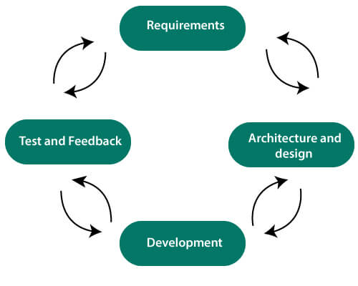

In the agile SDLC development process, the customer is able to see the result and understand whether he/she is satisfied with it or not. This is one of the advantages of the agile SDLC model. One of its disadvantages is the absence of defined requirements so, it is difficult to estimate the resources and development cost.

**Each iteration of agile SDLC consists of cross-functional teams working on various phases:**

Play Videox[](https://campaign.adpushup.com/get-started/?utm_source=banner&utm_campaign=growth_hack)

1. Requirement gathering and analysis
2. Design the requirements
3. Construction/ iteration
4. Deployment
5. Testing
6. Feedback

## How Agile Project Management works

The agile project management calls for teams to regularly evaluate cost and time as they move through their work. They use velocity, burnup and burndown charts to measure their work, rather than Gantt charts and project milestones to track progress.

The agile team practices to continuous development and continuous integration using technology that automates steps to speed up the release and use of products.

# What is Scrum?

**Scrum is a framework** that helps agile teams to work together. Using it, the team members can deliver and sustain the complex product. It encourages the team to learn through practice, self-organize while working on the problem. Scum is a work done through the framework and continuously shipping values to customers.

## What are sprints?

With scrum, a product is built in a series of repetition called **sprints**. It breaks down big complex projects into bite-size pieces. It makes projects more manageable, allows teams to ship high quality, work faster, and more frequently. The sprints give them more flexibility to adapt to the changes.

## What is sprint plan?

Sprint plan is an action in Scrum that kicks off the sprint. The primary purpose of sprint plan is to define what can deliver in the sprint. It also focuses on how the work will be achieved. It is done in combination with the whole Scrum team members.

The sprint is a set of the period where all the work to be done. Before we start the development, we have to set up the sprint. We need to describe how long time is required to achieve the sprint goal and where we are going to start.

## Factors affecting Sprint planning

* **The What:** The product owner describes the goal of the sprint and the backlog items which contribute to achieve that goal.
* **The How:** Agile development team plans its necessary work on how to achieve and deliver the sprint goal.
* **The Who:** The product owner defines the goal based on the value that the customers seek. And the developer needs to understand how they can or cannot deliver that goal.
* **The Inputs:** The product backlog provides the list of input stuff that could potentially be part of the current sprint. The team looks over the existing work done in incremental ways.
* **The Outputs:** The critical outcome of sprint planning is to meet described team goal. The product set the goal of sprint and how they will start working towards the goal.

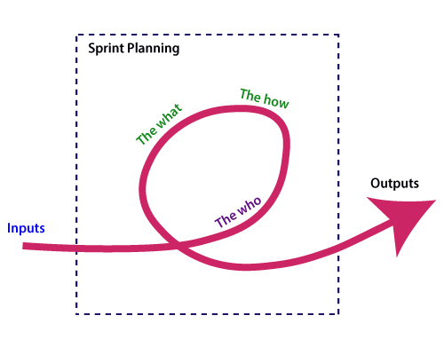

# What is Kanban?

Kanban is a popular framework which is used to implement agile software development. It takes real time communication of capacity and complete transparency of work. The work items are represented in a kanban board visually, allowing team members to see the state of every piece of work at any time.

## Boards

The kanban board is the agile project management tool that designed the necessary visualized work, limited work-in-progress, and maximizes flow (or efficiency). It uses cards, columns, and provides continuous improvement to help technology and service teams who commit the right amount of work and get it done.

### Elements of a kanban board

A person called David Anderson divides the kanban board into five different components. These are Visual signals, columns, work-in-progress limits, a commitment point, and a delivery point.

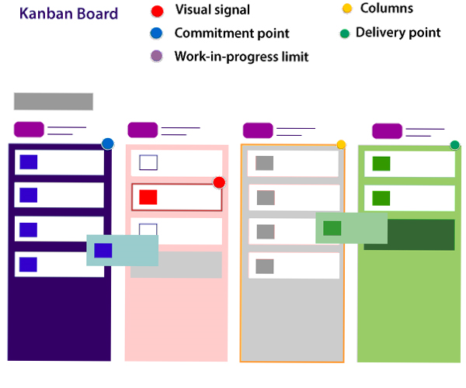

1. **Visual Signals:** The kanban board is a visual card (stickies, tickets, or otherwise). Kanban team write their projects and work items onto cards, usually per person each card. For agile teams, each card could encapsulate into one user story. Once the board completed, this visual team helps team members and stock members quickly to understand what the team is working.
2. **Columns:** The column represents the specific activities that compose a "workflow" together. The card flows through a workflow until its completion. The workflow may be a simple as "To Do," "In Progress," "Complete," or much more complicated.
3. **Work in progress (WIP) Limits:** The work in progress limits are the maximum number of cards which can be in one column. This is at any given time. It gives the alert signal that you committed too much work.
4. **Commitment point:** Kanban teams also maintain a backlog for their board. This is where the customers and team member put ideas for projects that the team can pick up. The team members pick up plans when they are ready. The committed point is a movement where the design is picked up by the team, and work starts on the project.
5. **Delivery point:** It is the end point of a kanban team's workflow. Mostly the delivery point for every team is when the product and services are handed to the customer.

## Kanban vs Scrum board

The following are the differences between Kanban and Scrum board:

Play Videox[](https://campaign.adpushup.com/get-started/?utm_source=banner&utm_campaign=growth_hack)

|  |  |
| --- | --- |
| **Kanban** | **Scrum** |
| Kanban is an ongoing process. | Scrum sprints have a start and stop dates |
| Kanban has no formal roles. | Role is clearly defined of each team in the scrum (product owner, development team, and scrum master). Both teams are self-organized. |
| A kanban board is used throughout the lifecycle of a project | Scrum board is cleared and recycled after each sprint. |
| This board is more flexible with regards to tasks and timing. Its task can be reprioritized, reassigned, or updated as needed. | This board has the number of tasks and a strict deadline to complete them. |

# Difference between Agile and Scrum (Agile vs Scrum)

[Agile](https://www.javatpoint.com/agile-methodology) is an iterative approach of software development methodology using short iterations of 1 to 4 weeks. Due to the agile methodology, the development process is aligned to deliver the changing business requirement. Using Agile methodology, the software is distributed with fasterand fewer changes.

[Scrum](https://www.javatpoint.com/agile-scrum) is a framework of agile that helps agile teams to work together. Using it, the team members development, deliver and sustain the complex product. It encourages the team to learn through practice, self-organize while working on the problem. Scum is a work done through the framework and continuously shipping values to customers.

# Agile Daily Stand-up

Agile daily stand-up is termed as the day-to-day status meeting on the project of the members of the agile team. The daily meeting of the agile team discussed the forum for regular updates as well as the problems of team members. It focuses on addressing the issues and tries to solve the issues quickly. The daily stand-up is the regular practice, no matter how an agile team is established regardless of its office location.

## What is Daily Stand-up?

The daily stand-up is a daily status meeting of the agile team member. This meeting roughly takes 12 to 18 minutes (an average of 15 minutes).

Each member of the team has to answer three important questions

1. What he/she did yesterday?
2. What he/she will do today?
3. The problem he/she is facing . . . He/she blocked due to. . .

The daily stand-up is done for a day-to-day status update. The meeting of team members with the product owner can be scheduled at different time. The participants in the stand-up meetings only stand instead of sitting so that the meetings get finished quickly.

## important of Stand-up:

The importance of having a daily stand-up in agile are as follows:

* The team can evaluate the progress report daily.
* The team member discusses all the progress and the commitments he/she made for the day.
* The members can also see whether they can deliver the project as per the iteration plan or not.
* Stand-up provides visibility to the team on any delay that occurs due to some obstacles.

## Who Attends a Stand-up?

* The project owner, scrum master, and the delivery team should attend the stand-up regularly.
* Customers and Stakeholders are encouraged to participate in the meeting, and they act as an observer. However, they are not supposed to participate in stand-ups.
* The responsibility of scrum master is to take note each team member's queries and the problems they are facing.

# Agile Definition of Done

Agile Definition of **done** is defined into three different stages called User Story (Requirement), Iteration, and product Release. These are given below:

## User Story (requirement)

A user story is a requirement which is formulated into few sentences. The user requirement is the everyday language of user. This user story should be completed within iteration. The user story is done when

* All the related code and documentation have been checked-in.
* The product passed all the processes of unit test.
* All the processes of the acceptance test case have been moved.
* The product owner must have accepted the story.
* The help text (documentation) is written.

## Iteration

An iteration is a time-based collection of a user story. It works on the defected product and accepted within the release of a product. Iteration is defined at the time of the iteration planning meeting and completed within the iteration demo and review meeting. The iteration is also known as a sprint. T

# Agile Software development

Agile development is more than a framework such as Kanban, Scrum, and Extreme Programming of Feature-Driven Development (FDD). It is more than practice, such as planning, test-driven development, planning sessions, stand-ups, and sprints.

# Agile Release Planning

The primary purpose of release planning is to make a plan to deliver an increment to the product. It is done in the interval of every 2 to 3 months.

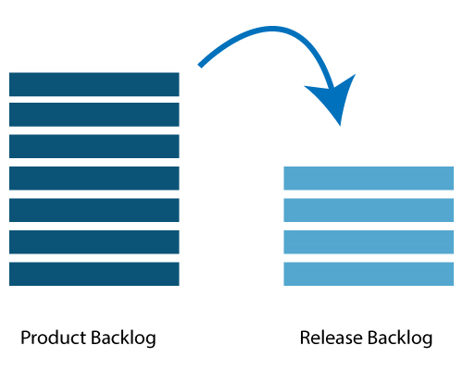

## Who is involved in releasing the plan?

Following person are involved in product releasing plan- Scrum Master, Product Owner, Agile Development Team, Stakeholders.

* **Scrum Master:** The Scrum Master is a team leader and facility provider who helps the team member to follow agile practices so that they can meet their commitments and customers requirements.
* **Product Owner:** The Product Owner is one who runs the product from a business perspective. He defines the requirements and prioritizes their values.
* **Agile Development Team:** Agile development team provides the judgment on the technical feasibilities or any dependencies.
* **Stakeholders:** Stakeholders are the customers, subject matter, program manager act as advisers in decisions which are made around the release planning.

# Agile Iteration Planning

The primary purpose of iteration planning is for the team. The team should be a complete set of the top-ranked product backlog items. The completion of top ranked product backlog is a commitment in the time needed on the length of iteration and team velocity.

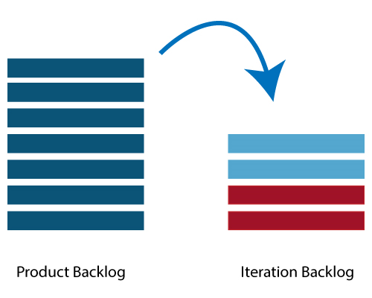

## Who involved in the iteration planning?

**Scrum Master:** The Scrum Master is a team leader and facility provider. He helps the team member to follow agile practices so that they can meet their commitments and customers requirements.

**Product Owner:** The Product Owner deals with a complete view of the product backlog and their acceptance criteria.

**Agile Development Team:** Agile delivery defines their tasks and sets the effort. The effort is to estimate the requirements to fulfill the commitment.

Play Video[](https://campaign.adpushup.com/get-started/?utm_source=banner&utm_campaign=growth_hack)

## Prerequisites of Planning

* The items in the product backlog are sized and have a relative story point assigned.
* The product owner gave the ranking to the portfolio items.
* Acceptance criteria of each portfolio item is clearly stated.

# Agile Product Backlog

The agile product backlog in [Scrum](https://www.javatpoint.com/agile-scrum) is a list of prioritized features. It contains a short description of all the functionalities desired in the product. In usual scenario, items should be broken down into user stories. Commonly, a Scrum team and its product owner write everything that they can think for agile backlog prioritization.

## Why Product Backlog is Important?

* The backlog is prepared to provide an estimate of each feature.
* It helps in the planning of the product's roadmap.
* It helps in the re-ranking the features of the product by adding more value to it.
* It assists in determining the priority of the product first. The team member works first on the higher prioritize product.

# Agile Tools

In agile development, leading as project management is not the easiest job. Jumping between your daily scrums to your next sprint, it causes hard to focus on the work. The agile development tools fulfill your needs, and does it for you.

**There are several agile tools available in the market. Some of them are listed below:**

### JIRA Agile

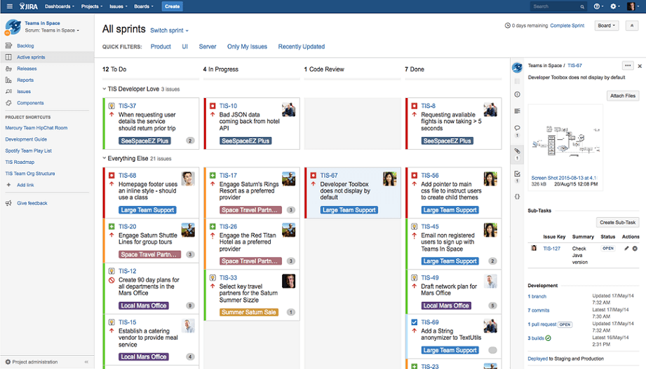

**Jira** is a tool developed by Australian Company **Atlassian**. It is used for **issue tracking, bug tracking, and project management**. The bugs and issues are related to your software and Mobile apps. The Jira dashboard consists of many useful functions and features. This function and features make secure handling of issues.

### Agile Software Features:

* Issue tracking
* Bug tracking
* Boards
* Epics
* Custom fields